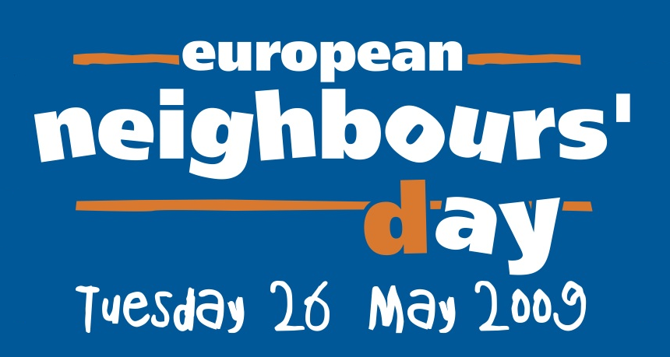

From Budapest to Brussels, from London to Lisbon, millions of people will be participating in events across Europe to celebrate European Neighbours Day on the 26th of May. And in Dublin it will be no different with activities taking place all over the City over a week long period. Through Dublin City Council’s Community Development Section, residents will be encouraged to host a wide variety of events to celebrate goodwill, reduce barriers of isolation and develop a better sense of community in our neighbourhoods.

EUROPEAN NEIGHBOURS’ DAY – EVENTS PROGRAMME 2009

- The finale to the dance programme for over 50s, ‘La Vie En Rose’ will take place in City Hall on Saturday, 23rd May at 2pm. Dublin City Council in association with one of Ireland’s premier contemporary dance companies, CoisCéim Dance Theatre, ran over 50 dance workshops throughout the City during April and May, in preparation for this event. These classes have given participants the chance to learn enjoyable dance sequences to the songs of Edith Piaf and 7 dance pieces will be performed on the day.

- Older people and people with disabilities are invited to a Creative Music Session in St. Andrew's Community Centre, 468 South Circular Road on Tuesday 26th May, from 10-12.30pm. Two musicians will be on hand to introduce people to a variety of musical instruments with an opportunity to learn to play them!

- David Day and African Drummers will be performing at Santry Community Resource Centre, Domville Court, Santry on Tuesday, 26th May from 2.30-5pm. Refreshments will also be served.

- Storytelling (for all ages) with Aideen McBride will be on offer at Ballymun Library, Ballymun Road on Tuesday, 26th May from from 3-4.30pm. Refreshments will also be served.

- Singalong and Dance event will take place on Wednesday, 20th May at 10.30am at the Macro Community Building, 1 Green Street, Dublin 7.

- A Health Awareness/Coffee Afternoon will be held between 2-4pm in Donore Hall, Donore Avenue, Dublin 8, on the afternoon of May 26th. The National Cancer Screening Service will be supplying an information stand and an Information Officer to answer any questions on Breast Cancer Screening and Cervical Cancer Screening. Local Community organisations will also be attending to offer information on the services offered within the Community. For further information please contact Paula Boylan, Assistant Community Officer on 087 749 6341.

- European Neighbours Day Lunch will be held between 12-2pm at C.E.C., 108 James Street, Dublin 8 on Tuesday, 26th May. Local Community organisations, residents as well as students from the centre will be invited to bring along their favourite dishes. For further information please contact Paula Boylan, Assistant Community Officer on 087 749 6341.

- ‘Let’s Walk & Talk’ is a great way for people to stay healthy, meet people and learn a little something about our Fair City. This initiative comprises weekly walks in various parts of the City, historical walking tours, nature walks and other special events. And ‘Let’s Walk & Talk’ will be inviting you and your neighbours to join us on some fascinating historical walking tours:

  - Saturday, 23rd May at 12 noon - “Hidden History – Dublin’s Legal Quarter Revealed”. Meet at Phoenix House, Phoenix Street North, Smithfield, Dublin 7 (Smithfield LUAS Station nearby)

  - Tuesday, 26th May at 2pm -“Historic Legacies from our Nearest Neighbour”. Meet outside The Barge Pub, Charlemont Street, Dublin 2 (Charlemont LUAS Station is nearby)

  - Thursday, 28th May at 2pm - “Sandymount - A Unique Village”. Meet at Sandymount Green in Sandymount Village (Buses 2,3 & 18 and Sandymount DART Station close by)

For further information, log onto www.letswalkandtalk.ie

- A Coffee Morning will be held in Fr. Maloney Hall, Drapier Road, Ballygall, Finglas East, Dublin 11 for the local community by Ballygall Women's Group. It will provide an opportunity for neighbours young and old to get together in a friendly social setting with light refreshments served. Entertainment on the day will be provided by the Forever Young Chorus who are a group of older persons in the Finglas community, who come together to perform at local events.

- A Coffee Morning for the local community will also take place in the offices of Project West C.D.P., Barry Shopping Complex, Finglas West, Dublin 11. At this event, the community will have an opportunity to find out about what services their local C.D.P. provide whilst entertainment on the day will include storytelling which is a feature of the Bealtaine Festival programme.

- Finglas South C.D.P. are planning to organise a Morning of Entertainment for users of St. Helena's Family Resource Centre. Those attending will have an opportunity to participate in an African drumming session, which displays and promotes local African culture. Again this activity is a feature of the Bealtaine Festival programme. Finglas South C.D.P. are based at St. Helena's Family Resource Centre which is on St. Helena's Road, Finglas South, Dublin 11

- Dublin City South Volunteer Centre are also joining in the celebrations again this year and have arranged a Community Fair in Ballyfermot Library from 12-2pm on European Neighbours Day itself. Voluntary and community groups will have a stand and refreshments will be served for everyone. Volunteers will be out in force that morning too, welcoming everyone in the locality, telling them it’s neighbour’s day, inviting them in and giving them a sticker that says ‘I’m a good neighbour’!

More events, ranging from street parties to environmental projects to tea parties are yet to be confirmed!

For further details and updates, please contact Ronan O’Donnell on 2223726 or visit www.dublincity.ie


